# COMP 3512 Assignment #2

*Due Thursday December 10th at noon  
Version 2.0, November 19 (changes in yellow)*

## Overview

This assignment is a group project that expands your first assignment in functionality and scope. It is broken into several milestones with different dates. The milestones are in place to ensure your group is progressing appropriately.

Some of the specific details for some of the milestones and pages will develop over time; that is, this assignment specification is a living document that will grow over the next several weeks.

## Composition

You can work in groups of three or four or five for this assignment. It is also possible to work individually or in a pair, but I do discourage it; please talk to me about this if you are planning on working by yourself or as a pair. Don’t ask me for a group of six or more: the answer will be NO.

If working in a group, each member needs to take responsibility for and complete an appropriate amount of the project work. **Be sure to consult the instructor at least one week prior to any due date if your group is experiencing serious problems in this regard (but by then it’s almost too late). If you are having problems two weeks before the due date with a group member, then there is probably a sufficient amount of time to rectify the problems!**

I feel foolish saying this in a third-year university course, but it is your responsibility to read all the assignment instructions thoroughly and carefully. If you are unclear about something, ask me. But before you do, read the material in question again!

## Files

You will be able (eventually) to find the most recent version of the database scripts and all the images at the GitHub repo for the assignment:

https://github.com/mru-comp3512-archive/f2020-assign2  
 *Note: github repo is now ready (November 19)*

Periodically, I may upload a revised version of the database script on GitHub. If I do so, simply re-running the script file (e.g., using the MySQL command source art-3rd.sql) will remove your previous tables and re-create and re-populate them).

## Source Code Approaches

You need to have *“a single source of truth”* when it comes to your source code. That is, there must be a “master” location that contains the definitive version of your source code. There are two approaches you can take for your source code in this assignment.

* **Team Leader**. In this case, the team leader will take responsibility for maintaining the most up-to-date code.
  + *Advantages*:
    - simplest approach (don’t need to learn git)
  + *Disadvantages*:
    - Better hope team leader doesn’t make a mistake,
    - If that person is not available, then where do you get the most recent code?
* **GitHub**. In this case, there will be a single github repo that will be the “owner” of the source code. Each member will be added as collaborators to the repo. Members will work locally using whatever technology they want. They will then push code to this single github repo when needed. Alternately, members will have to pull the current version of their branch before coding or each member will have to have different branches and then these branches will have to be merged. This is the workflow you will see in industry … it’s complicated but employers today expect their prospective employers to already know it.
  + *Advantages*:
    - group members can use whatever technology they want for editing and running,
    - any github pushes will be “credited” to the person who did the push
    - gain very useful real-world experience working with git+github branches and merges.
    - Most hosting environments work with github
  + *Disadvantages*:
    - Everyone will have to learn and deal with git branching + merging (which can sometimes be frightening).

## GitHub

Regardless of the source code approach you take, each group member will need their own Github account. You will also need to create a private repo on Github for the assignment. You have a couple of ways to do this. One way would be for one member in your group to create it (they would thus “own” the repo), and then add other members as collaborators.

The free GitHub account doesn’t allow private repos; if you sign up for the Student Developer Pack (<https://education.github.com/pack>) you can have free private repos while a student. The other way is to email me, and I can create a private repo under our department’s github organization (<https://github.com/MountRoyalCSIS>) for your group. You would need to supply the github names or emails for each member. You can also decide to use a public repo.

You will want to push out updates fairly frequently (1-2 times a day when working on it, or more frequently if lots of work is being done). I will examining the commits when marking. You can push your content to GitHub via the terminal, using the following commands (not the stuff in square brackets though, as those are comments):

**git init** *[only need to do this one command once for your assignment]*  
**git add \***  
**git commit –m "Fixed the rocket launcher"**  *[alter message and name as appropriate]***git remote rm origin** *[just in case your cloud9 workspace still linked to my github]***git remote add origin https:... *your-repo-url*.git** *[specify URL of github repo … do this just once]*  
**git push –u origin master** *[login using your own individual github credentials]*

For more information about Git and GitHub, read pages 571-577 of textbook (2nd Edition). There are many online guides to git (for instance, <https://guides.github.com/introduction/git-handbook/>).

## Grading

The grade for this assignment will be broken down as follows:

Visual Design and Usability 15%

Programming Design and Documentation 08%

Hosting 07%

Functionality (follows requirements) 65%  
Milestones 05%

## Submitting and Hosting

You will be using JavaScript, PHP, and MySQL in this assignment. Eventually this will mean your assignment will need to reside on a working host server. In the labs, you made use of XAMPP on your local development machine as both host server and as a development environment. While easy, it means no one but you (or your group members and myself) can ever see your work. If you ever want to use your assignment as a portfolio piece, it needs to be on a working host server. Static hosts used in the first assignment will not work for this one.

For this assignment, these are your hosting/submitting options:

* Heroku. It has a free tier and is a popular hosting option that integrates nicely with github. It requires that at least one person register with heroku and install its CLI software on their computer. That person then uses a few command line instructions to copy software from github repo to the heroku servers. Some additional commands are needed to add mysql (or MariaDB which is the same thing) via third-party marketplace. Lots of online instructions available (try searching for “deploy PHP mysql heroku”). Will take some time to set up. I will provide a lab that illustrates this option.
* Digital Ocean. Similar to Heroku. You can also find free credits via Git Education program.
* Inexpensive Hosting. These usually won’t be free (often about $5/month), but some are free. Once setup, your site can live forever. Possibilities include epizy, infinityfree and bluehost.
* Google Cloud Platform. In this case, you will setup a virtual LAMP stack on a Compute Engine (a virtualized server). Will be likely too expensive over time, but you can get free credits that will last for a few months. I will provide a lab that illustrates this option.
* Amazon Web Services (AWS). Similar to Google’s offerings. Will be likely too expensive over time, but you can get free credits that will last for a few months. Probably easiest approach is launching LAMP stack on AWS Lightsail (first month for lightsail is free).
* Make use of a Docker LAMP container and then deploy container on any host environment that supports Docker. This will provide experience in the most important DevOps platform and will thus be excellent to put on your resume.

This step is going to take some time, so don’t leave it till the very end. I would recommend assigning this task to someone in group who feels comfortable with operating systems and networking; because this takes time, you should ask that person to do a bit less programming. **The hosting should be arranged and tested (i.e., verify PHP and MYSQL work) well before the assignment is completed!!!**

When your hosting is working and the assignment is ready to be marked, then send me an email with the following information:

* The URL of the home page of the site on your hosting platform.
* The names of the other people in the group
* The URL of the github repo so that I can mark the source code. If your repo is private, then add me as a collaborator.

## Emergency Database Hosting

If you are having no luck at all getting your MySQL database working, you can try (with a small mark penalty), to use either the SQLite database, or connect to my MySQL database. If you chose the latter, email me at least a day before the deadline so I can create a temporary account for you and then send you the connection string and user name information.

## Milestones

You will need to implement certain functionality by specific dates. You will show me your completed milestones in the lab on the dates shown below.

**Milestone 1**.   
*Due Nov 13.*

You must decide on your group members and set-up your github accounts. Send me an email with each group member’s name and the URL for each member’s personal github page. Also provide URL for the main github page for the assignment.

**If you don’t have a group by the morning of Nov 10, please email me and let me know; I will try to get you into a group during the lecture.**

**Milestone 2**.   
*Due Nov 27.*

Create the following APIs in PHP.   
api-galleries.php – with no parameter, return a brief JSON representation of all galleries. If supplied with id parameter, then return just JSON data for single specified painting.

api-paintings.php – with gallery parameter, return a brief JSON representation of all paintings that match provided gallery id.

## Data Files

Data in this assignment will come from MySQL. You will be provided with the import scripts for them. I have also provided a SQLite version in case you need it.

## Functionality

Your second assignment will replicate some of the functionality from assignment 1, but is **not** a single-page application; instead multiple pages in PHP are needed. Some of these pages also use JavaScript but others don’t.

**Visual Design:** Your pages will be marked on a desktop computer, but your site needs to be usable at mobile sizes. That is, I will be mainly testing and evaluating this assignment using a browser with a large browser width, say 1200 pixels wide. You should still use media queries as I will also test your pages with a smaller-width browser size to ensure it looks “reasonable” at a mobile size. That is, you will likely want to switch to a smaller number (one or two) of grid columns at a mobile size.

If you wish, you can make use of a third-party CSS library. Be sure to document this usage in your about page.

**Header**: Each page will have a header at the top that will contain some type of logo and a navigation menu. For smaller browser sizes, you will instead need a “hamburger” menu, that is, a responsive navigation bar. There are many examples online of the necessary CSS and JavaScript for this to work. If you make use of CSS+JavaScript you find online, please be sure to document this in the About page. The header/hamburger menu should have the following links/options:

* Home
* About
* Galleries
* Browse/Search Paintings
* Favorites. Should only be available once user is logged in.
* Login/Logout. If user is not logged in, then the option should be Login; if user is already logged in, then option should be Logout.

Note: the sketches in this assignment specification are meant to show functionality, not design. Here I’ve shown content as boxes, but you could do them as rectangles, circles, icons, simple links, etc. Make your pages look nicer than these sketches!

**Home (Not Logged In)**: The main page for the assignment. This file **must** be named index.php. This must have the functionality shown in the following sketches. The first shows the home page when user hasn’t logged in; the second show the home page after a user has logged in.

A hero image is a large banner image: you can find attractive very large images on unsplash.com. The search box should take the user to the browse/search page (i.e., it should show results as if the user performed a painting title filter action).

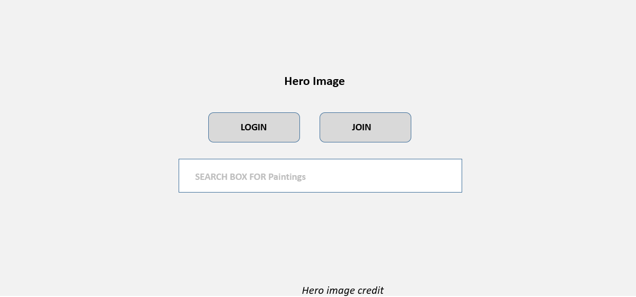

**Home (Logged In)**: Display the user info (first name, last name, city, country). Also display paintings they have put on their Favorite list (if none yet, be able to handle that).

Also display 10-15 recommended paintings the user “may” like. How to do this? Ideally, if you had several additional months to work on this assignment, you would create a recommendation engine using some type of Machine Learning algorithm. But given the time constraints, your list will be based on paintings that the user has already favorited. That is, create a list containing:

* paintings with the same artist as one of the favorited paintings
* paintings from the same era rating as one of the favorited paintings

It’s possible that a user hasn’t favorited any paintings yet; your algorithm must be able to handle this situation. In that case, show first 10-15 paintings in the table. If your Paintings You May Like algorithm has fewer than 10-15 images, fill it up with these same paintings.

Each of these painting images should be links to the single-painting.php page with the painting id in the query string.

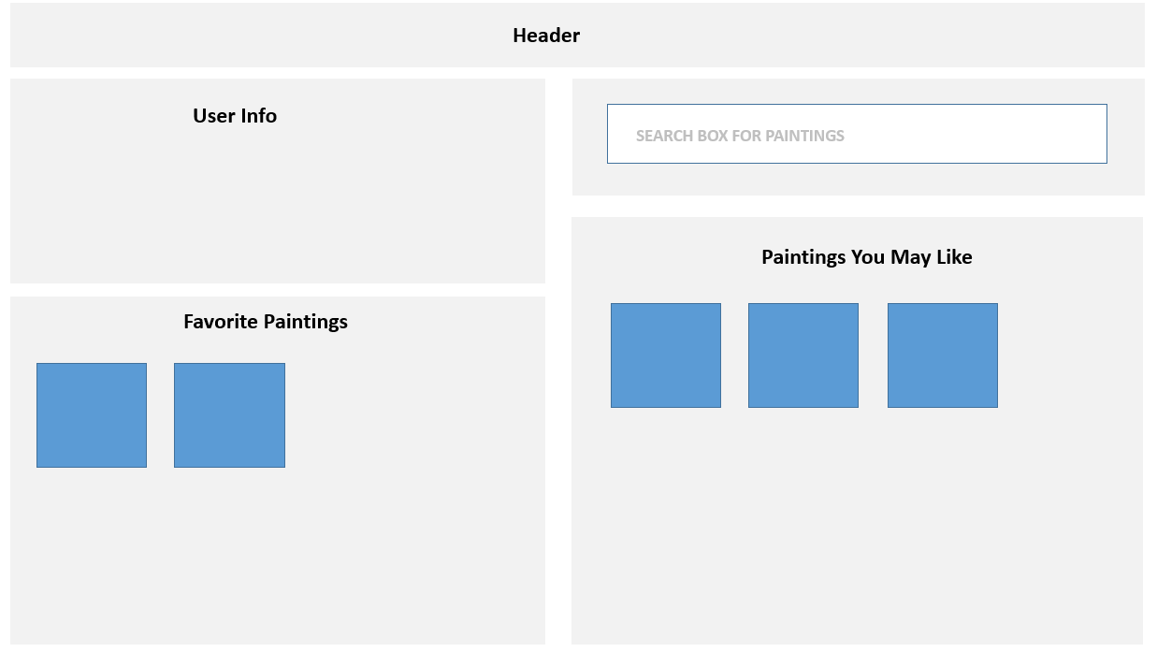

**Galleries Page**: This page should be named galleries.php. Displays a list of galleries with similar functionality as the first assignment. Most of the functionality on this page should all work via JavaScript so you should be able to make use of most of your assignment 1 JavaScript code here. Your page’s JavaScript will make fetch the galleries from the API you create (instead of mine). When the user clicks on a gallery in the gallery list, display gallery details, gallery map, and a list of paintings; this will require JavaScript event handler.

To improve the performance of your assignment, you must store the content retrieved from the gallery API in local storage after you fetch it. Your page should thus check if gallery data from this API is already saved in local storage: if it is then use it, otherwise fetch it and store it in local storage. Be sure to test that your application works when local storage is empty before submitting.

The paintings for the selected gallery will be retrieved from your paintings api.

The headings at the top of each column (Artist, Title, Year), should be clickable. When the user clicks on a column heading, the painting list will be redisplayed so that it is sorted on the value just clicked. When first displayed, sort by year. The display and sorting will be done in JavaScript.

The painting titles will be working hyperlinks. When the user clicks on the link, it will take the user to the **Painting Details** page with the painting id has a query string (e.g., single-painting.php?id=17).

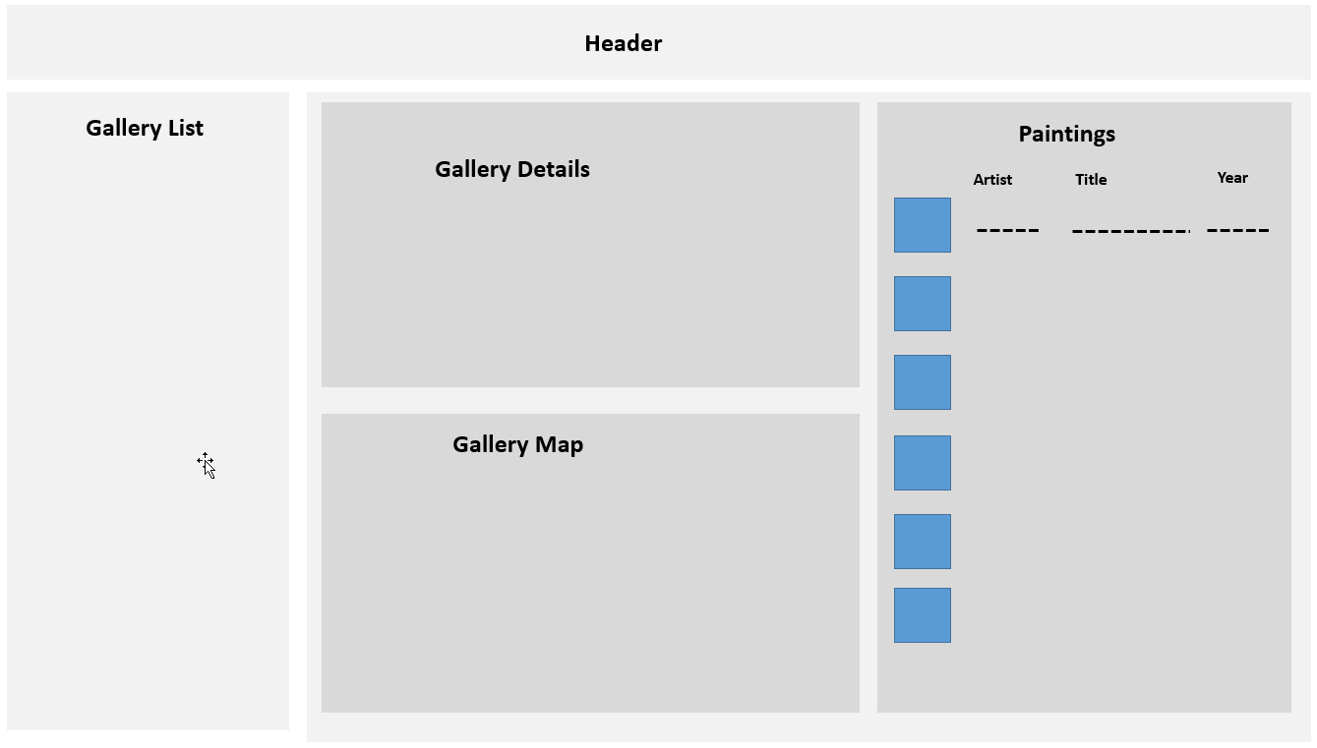

**Search/Browse Page**: This page should be named browse-paintings.php. Displays a list of paintings with filter functionality and sorting. Instead of using JavaScript for the paintings, you will do all the display using PHP.

The painting list should initially be sorted alphabetically on year. Initially, display all paintings (or filtered by name depending on what happened on the Home View).

The painting titles will be working hyperlinks. When the user clicks on the link, it will take the user to the **Painting Details** page with the painting id has a query string (e.g., single-painting.php?id=17). The View button will do the same (that is, style a link to look like a button). Add to favorites will be described later. Don’t be afraid to use icons instead of words.

The filter form provides a way for user to filter the paintings. Filtering will be implemented in PHP using SQL WHERE. If the user specifies multiple filters, assume they have AND values (e.g., WHERE Title Like ‘%Port%’ AND Year < 1500).

Artist and Gallery <select> lists will be filled in PHP, and will contain a list of artists (sorted by last name), and gallery names (sorted by name). For both, provide an empty default (e.g., <option value=0></option> or <option value=>Choose an artist</option>).

The Clear button resets the filter form. When the user clicks the Filter button, then perform the filter. Make the form’s method=GET and its action=browse-paintings.php. This means your page will have to examine $_GET and examine which query string parameters have been provided.

The Year, Title, and Year column headings should be clickable: when clicked they sort the paintings by that field. Here, though, the filtering will happen in PHP using SQL ORDER BY. This will require using query strings (e.g., <a href=browse-paintings.php?sort=year&[other querystrings]>Year</a> ).

Clicking a sort should preserve the filters. You will thus have to programmatically generate the query string based on the current state of the $_GET variables: e.g.,

<a href=browse-paintings.php?sort=year&title=Port&artist=&gallery=&year1=1500>Year</a>

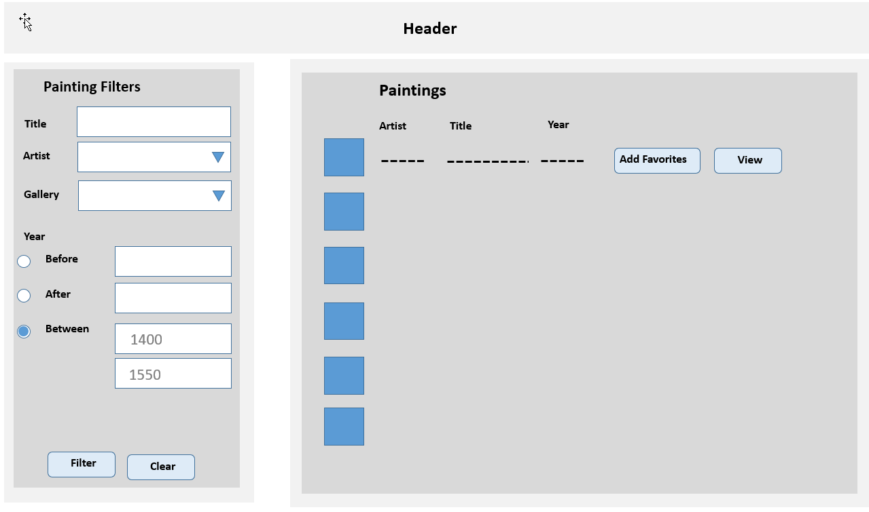

**Painting Details Page**: This page should be named single-painting.php. It should display the single painting indicated by the passed querystring parameter.

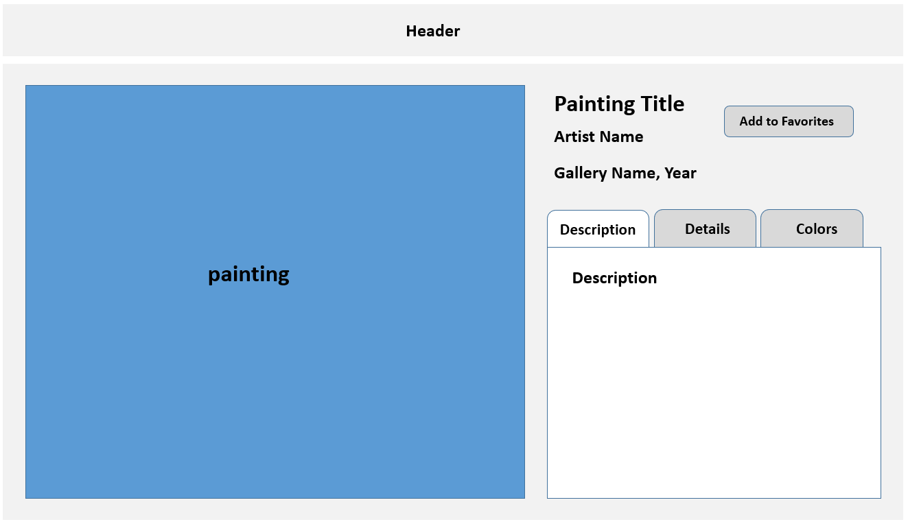

I expect this data to be nicely formatted and laid out sensibly. Every year students lose easy marks because they put no effort into the layout here.

You must implement some type of tabs interface using JavaScript (simply hide/unhide divs when tab label is clicked). These tabs will contain:

* Description: description field
* Details: medium, widfth, height, copyright text, wikiLink, museum link. These last two should be working links.
* Colors: display the dominant colors field (color box, hex, color name)

You will need to add an Add to Favorites link styled as a button. This will add the painting to a session-based list and provide feedback that it has been added. You will do this by redirecting to a PHP page that adds the painting to the session list, and then redirects back to this page. This is easiest but old fashioned and inefficient; it results in two redirects (two request+response cycles).

This add to favorites button must only be visible if the user is logged in. If a painting is already favorited, you shouldn’t be able to add it again. Ideally, you do this by hiding/disabling the button. Alternately, you display a message telling the user it’s already been favorited.

**Favorites Page**: will display list of logged-in user’s favorited paintings (implemented via PHP sessions). If none yet, be able to handle that with a message. This page must be named favorites.php. The user should be able to remove paintings singly or all at once from this list. This page will be entirely in PHP. The list should display a small version of the painting poster and its title. They both should be links to the appropriate single painting page.

**About Page**: Provide brief description for the site, by mentioning class name, university, professor name, semester+year, and technologies used. Also display the names and github repos (as links) for each person in the group. Add a link to the main assignment github repo. Every year, for unknown reasons, students lose easy marks by not fulfilling these simple requirements.

Just like in assignment 1, be sure to provide credit for any external/online CSS/JavaScript/PHP you have made use of in this assignment.

**Login Page**: will display a login screen with email and password fields, plus a login button and a link or button for signing up if the user doesn’t have an account yet. Some of the information below about hashing algorithms will be explained in class when we cover security.

Your database has a table named CustomerLogon. It contains the following fields: id, firstname, lastname, city, country, email, password, salt, password_sha256.

The actual password for each user is **mypassword**, but that’s not what is stored in the database. Instead, the actual password has been subjected to a bcrypt hash function with a cost value of 12. The resulting digest from that hash function is what has been stored in the password field. That means to check for a correct login, you will have to perform something equivalent to the following:

$digest = password_hash( $_POST['pass'], PASSWORD_BCRYPT, ['cost' => 12] );

if ($digest == $password_field_from_database_table && emails also match) {

// we have a match, log the user in

}

For successful matches, you will need to preserve in PHP session state the log-in status of the user and the user’s id. As well, after logging in, redirect to the **Home** page.

**Logout**. If the user is logged in, then modify your session state information so your program knows a user is no longer logged in. After logging out, redirect to **Home** page.

## Recommendations

1. Start by completing Lab14.
2. This is a data-driven site, so I would recommend beginning by constructing the table gateway classes in PHP: use the ones in Lab14a as your model.
3. Implement the second milestone.
4. Implement painting details, then search browse.
5. Implement galleries
6. Implement favorites
7. Implement the login.
8. Implement home page.

Steps 5-8 can be done asynchronously, perhaps by different team members.